# PROFESSIONAL EXPERIENCE

BERINDEI FINEAS

FRONT-END DEVELOPER

**3/12/2017 -**

**- 7/1/2018**

**8/5/2018 -**

**3/12/2019**

**3/3/2020 -**

**1/6/2021**

## BestTrading.fr

web developer, Timisoara Development/deployment of sites and web apps with UX/UI best practices, mainly focusing on responsiveness and maintenance of code.

Technologies: Wordpress, Joomla, Bootstrap,

Javascript, CSS3 and HTML5

## mediatack GmbH

Junior front-end developer, Timisoara Collaborated in a team-focused environment, working on web apps and websites, offered to a diverse industry class of clients. Technologies: Javascript, Bootstrap, Angular 8, HTML5, CSS3.

## Dexwell.US

Front-end developer, San Diego

Working on full-stack apps using Angular on Frontend and C# .Net on the backend. We provided web apps dashboards for doctors offices and multinational companies.

# EDUCATION

**15/8/2015 -**

**7/22/2018**

## Bachelor degree in Physics and Informatics and Master in informatics

UVT, Timisoara

Studied quantumum physics and Web development.

# CONTACT

SKILLS

## frontend skills

Angular 8+ RxJs

Api JavaScript/Type SCript

Http protocol, RESTful services Json

Design Patterns HTML, SCSS,

Bootstrap Git



















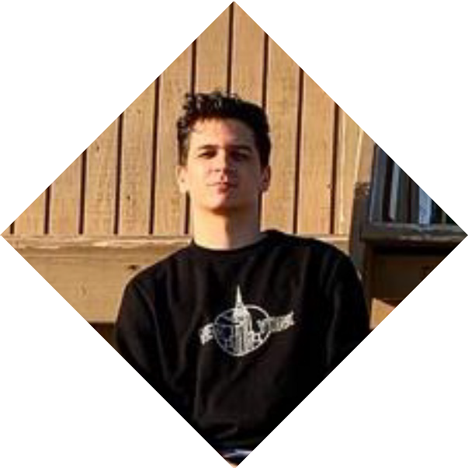

 Anaheim Los Angeles

 7148121511

→ [fberindei@dexwell.com](mailto:fberindei@dexwell.com)

↑ fineas.berindei

 @BFineas

 /fineas.berindei



# PROJECTS

**Personal Website: https://fineas-portfolio.netlify.app/**

**Movie App using Javascript, Restful Api: https://movieapp- fineasinc.netlify.app/**

**Weather App using Javascript, weather Api, Json data, Bootstrap and more: https://weatherapp-fineasinc.netlify.app/**

**Weather App using Angular 8+, RxJs, TypeScript, Http protocol and more: https://weatherappangular-fineasinc.netlify.app/**

**Doctor dashboards: Unfortunately the projects are private. Wordpress websites for companies in Real Estate Hotels and so on.**

# ABOUT ME

I am a very hard working person, who will never stop learning new technologies about web development. In present I am working on a quiz full stack web app who will test kids all over the world about subjects like Biology, Geography, and so on. I am very passionate about what I am doing and I think I am great teammate who likes to help others as well.